МКОУ «Ботлихская СОШ №2 им. Р.Алиева»

.

Конспект
урока по английскому языку в 5 классе по теме:
“Home, sweethome”

(с применением здоровьесберегающей технологии)

Провела:
Набиюлаева Купра Гамбулатовна,
учитель английского языка.

План-конспект открытого урока по теме “Home, sweethome”.
Цель урока:
- Закрепление полученных лексических и грамматических навыков по теме “Home, sweethome”.
Задачи урока:
Образовательные:
- Повторение лексики и грамматики по теме.
- Формирование у учащихся навыков общения в рамках речевой ситуации «Мой дом».
Развивающие:
- Развитие умений и навыков чтения и письма.
- Развитие коммуникативных навыков: умения вести диалог и монолог на английском языке.
- Тренировка памяти учащихся.
- Тренировка внимания.
- Развитие навыков аудирования.
Воспитательные:
- Воспитать у учащихся интерес к английскому языку, уважение к культуре и традициям страны изучаемого языка.
- Воспитать умение работать в коллективе, слушать других и помогать друг другу.
Тип урока: комбинированный.
Форма и виды работы: индивидуальная, фронтальная, групповая.
Оборудование урока:
- мультимедийный проектор;
- буклеты с упражнениями;
- магнитофон;
- работы учащихся.
План урока:
- Организационный момент – 2мин.
- Фонетическая разминка. Отработка звуков [i], [i:], [u:] – 3 мин.
- Повторение лексического материала по теме – 5 мин.
- Аудирование диалога по теме – 5 мин.
- Физминутка – 1 мин.
- Работа с текстом. Отработка навыков чтения – 8 мин.
- Просмотр видеоролика – 4 мин.
- Презентация проекта «Мой дом» - 8 мин
- Исполнение песни – 2 мин.
- Подведение итогов урока, запись домашнего задания, выставление оценок – 2 мин.
Ход урока
1
T: Goodmorning, boysandgirls… I`mverygladtoseeyoutoday.How are you?
Ps: Fine.
T: OK, then. Let`s start our work. What date is it today?
P1: The 14th of March.
T: What day is it today?
P1: Thursday.
T: Who is absent today?
P1:
T: OK. At the lesson we are going to revise “Home, sweet home” theme. On your desks there are Exercise Booklets with all exercises in them. Sign them, please. Write down your names and surnames.
2
And now let`s begin from phonetic exercises as usual. Please, devide into two groups. The first group includes the pupils in the row in front of the window and the second group includes the pupils in the row near the door. So, look at the board. You see a text there. The text is called “My house”. The pupils in the first row will say after methe red lines of the text and the pupils in the second row will say after me the blue lines of the text. Let`s begin.
T: My House
Let's go to my house.
Ps (1): Let's go to my house.
T: Let's go today.
Ps (2): Let's go today.
T: I'll show you all the rooms
Ps (1): I'll show you all the rooms
T: Where we work and play.
Ps (2): Where we work and play.
T: Here is the kitchen
Ps (1): Here is the kitchen
T: Where Mother cooks for me.
Ps (2):Where Mother cooks for me.
T: Here is the living room
Ps (1): Here is the living room
T: Where I watch TV.
Ps (2): Where I watch TV.
T: Here is the dining room.
Ps (1):Here is the dining room.
T: We eat here every day.
Ps (2):We eat here every day.
T: And this room is my room
Ps (1):And this room is my room
T: Where I sleep and play.
Ps (2):Where I sleep and play.
3
T: Great. And now let`s revise the words. I have got some sheets of paper with different sentences in them. The task is: I show you a picture and you describe it with the sentences you`ve got.
The first picture is “a house”
P1: The house is white.
P2: The house has got two floors.
P3: There is a garage next to the house.
P4: There is a small garden around the house.
T: The second picture is “a garden”
P1: There are many trees in the garden.
P2: There are many bushes in the garden.
P3: There are many flowers in the garden.
T: The third picture is “a garage”.
P1: The garage is white.
P2: There is a car in the garage.
T: The next picture is “a kitchen”.
P1: There is a fridge in the kitchen.
P2: There is a cooker in the kitchen.
P3: There is a table in the kitchen.
P4: There are two chairs in the kitchen.
T: The next picture is “a dining-room”
P1: I have dinner in the dining-room.
P2: The dining-room is very light.
P3: There is a table and four chairs in the dining-room.
T: The next picture is “a living-room”
P1:There is a sofa in the living-room.
P2: There is a coffee-table in the living-room.
P3: There is a TV-set in the living-room.
T: The next picture is “a bedroom”.
P1: There is a bed in the bedroom.
P2: There is a mirrorin the bedroom.
P3: There is an armchairin the bedroom.
P4: There are two pictures on the wall in the bedroom.
4
T: Right you are. And now listen to the dialogue and try to answer the question: Where is Rachel?
Sue: Hello, Mrs Kane. I`m Sue. Is Rachel here?
Mrs Kane: Hello, Sue. Rachel`s in her bedroom.
Sue: Sorry, where`s that?
Mrs Kane: It`s next to the living-room.
Sue: OK, thanks… Rachel, I`ve got a new poster for you. Rachel! Where are you?
Rachel: Here I am – under the bed. I can`t find my little mirror. Ouch! My head!
Sue: Oh, Rachel!
T: So, my friends, where is Rachel?
P1: She is under the bed
T: You are right. And now look at the nextexercise in your booklets. Mark the sentences 1 to 4 true or false. Look at the sentences. (1)Sue is Rachel`s sister; 2) Rachel`s bedroom is next to the living-room; 3)Rachel can`t find her cushion; 4) Sue has got a poster for Rachel) Listen to the dialogue once more and do the task.
- Sue is Rachel`s sister _____
- Rachel`s bedroom is next to the living-room ______
- Rachel can`t find her cushion _____
- Sue has got a poster for Rachel _____
T: Are you ready to answer? Read the first sentence and agree or disagree.
P1: …False.
T: The second sentence.
P2: … True.
T: Sentence 3.
P3: … False.
T: Sentence 4.
P4: … True.
5
T: You are right. Thank you. And now
Stand up and look around,
Count to three (one, two, three) and turn around;
Stamp your feet upon the ground,
Clap your hands and then sit down.
6
T: So, the next task in your booklets is to read the text and colour the picture. Read the text.
P1: This is …
T: Thank you. What pencils do we need to paint the picture?
P2: Blue, yellow, green, red and pink.
T: Right you are. Paint the picture, please. You`ve got three minutes.
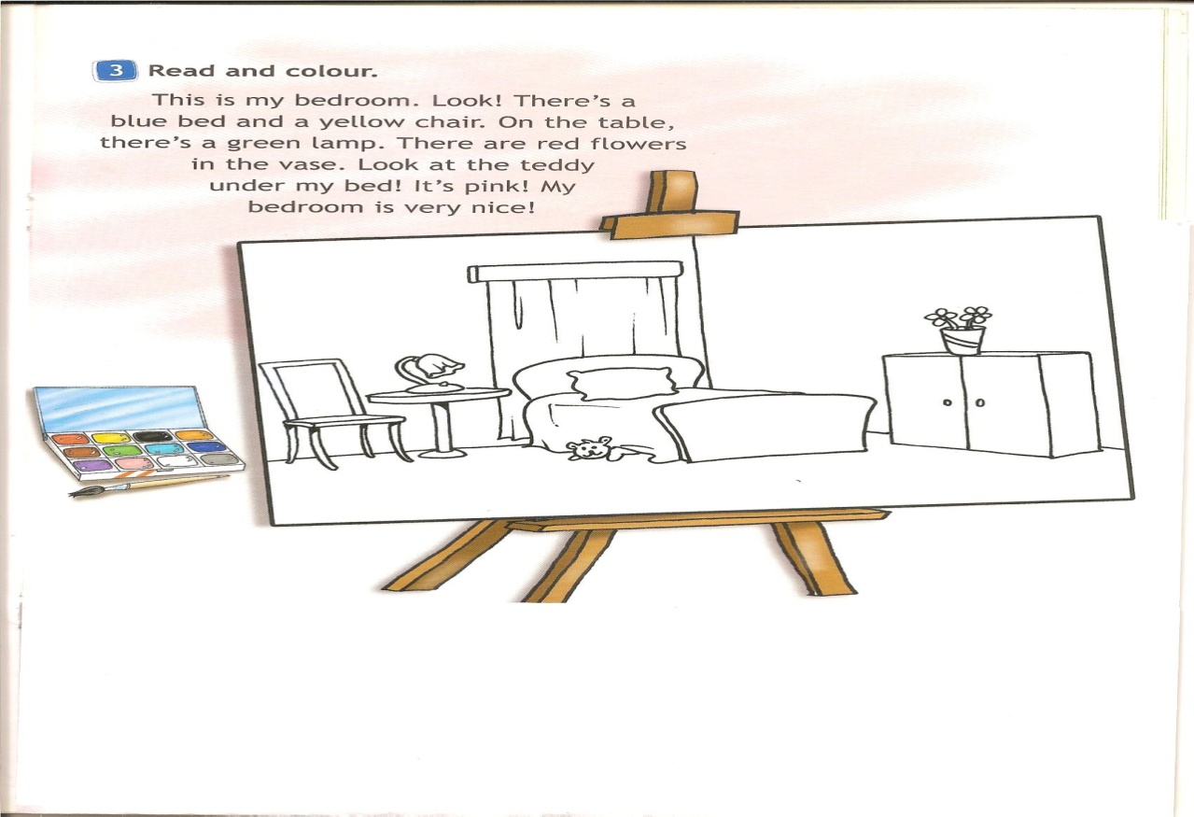
T: Who is ready? Who wants to show us the picture? … What colour is the bed?
P1: It`s blue.
T: What colour is the chair?
P2: It`s yellow.
T: What colour is the lamp?
P3: It`s green.
T: What colour are the flowers?
P4: They are red.
T: What colour is the teddy?
P5: It`s pink.
7
T: Fantastic! Let`s watch the film about British home.(Window on Britain 1: 17-20 min.)
T: What rooms are there in this house?
P1: There is a living-room, a kitchen, a dining-room, a bathroom, and a bedroom.
T: Great. You are right.
8
T: And now let`s listen to the stories about your homes. At home you were to make projects. … show us the picture of your house and tell us about it, please.
P1: My house is very big. There is a kitchen, a living room, three bedrooms and two bathrooms. There is a big sofa and two armchairs in the living room. Look at my bedroom. There are two beds in it. Look at all the flowers in the garden. Our house is lovely.
T: Thank you. …
P2: My house is very big. There is a kitchen, two living rooms, four bedrooms and two bathrooms. Look! There is a big table and six chairs in the kitchen. This is my bedroom. There is a nice computer in it. Look at all the trees in the garden. Our house is lovely.
9
T: Thank you very much. And now let`s sing the song about a funny house.
Ps: My house is very funny.
My new house is funny.
There are boxes everywhere:
Boxes in the cupboards,
Boxes on the chairs,
Boxes on the table,
And some under my bed.
And there are two men in the kitchen
With boxes on their heads.
10
T: Great. Thank you very much for your brilliant work at this lesson. Everybody gets excellent marks. Now open your record-books and write down your home task for Monday. At home you must write a story about your bedrooms. The time is up now. The lesson is over. You may be free. Good-bye.
Ps: Good-bye.

